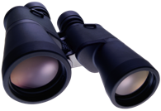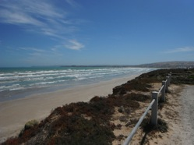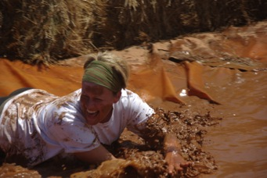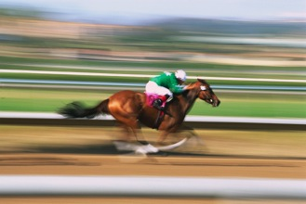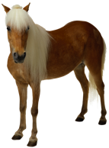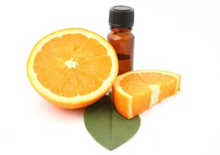

# Did you know..

**In November 1957** - Soviet Russia launched the world's first inhabited space capsule, Sputnik II, which carried a dog named Laika. I know there are many pet lovers owners amongst you, so for the month of November I am offering a complimentary neck and shoulder Bowen treatment with every one hour massage purchased. You can either use this at your next massage or give it to a friend who might have tension in this area from the dog that’s always pulling on the lead ☺

For appointments please contact Andrea on 0423 620 320

<http://www.remedialtherapiessa.com.au>

### In this issue

Did you know...

MS Mud Run

Melbourne Cup

Aromatherapy – orange oil

Treatment Menu

November 2013 Newsletter

###### As promised I am putting up a photo of me participating in the MS Mud Run. This photo was taken at last year’s run. I will be participating again this year, on Sunday the 1st December so if you want to make a donation, participate or come and laugh at me, there is still time! The MS Mud Run is a fundraising event for Multiple Sclerosis and takes place at Urrbrae High School. I really have no idea why they call it a “run” because if you ask me, there is no way I can run with that much mud squelching around in my shoes! The course however is filled with mud and obstacles and is fun for the whole family . You don’t need to be fit as long as you don’t mind getting a bit dirty, and it is for a good cause. Hope to see you there.

For appointments please contact Andrea on 0423 620 320

<http://www.remedialtherapiessa.com.au>

Traditionally the Melbourne Cup is always held around this time of the year. If you are going to a luncheon here’s just a few tips to ensure you make the most of it:

1. If you do place a bet make sure you don’t put more on a horse than you are willing to part with because not every one can be a winner.
2. Drink plenty of water so your body can cope better with the event of the day eg food, alcohol, stress, heat
3. If you must wear high heels (Ladies) make sure you have a flat pair of shoes to walk to the car with, and try not to stand all day as this puts undue stress on your back, hips, knees, neck, and ankles.

Melbourne Cup

# MS Mud Run

Orange oil is one of the key components extracted from orange peels. Orange oil is extracted from the small glands found on the orange peel. Have you ever been sprayed by tiny bursts of scented liquid when peeling an orange? These are caused by the rupturing of the glands underneath the orange peel.

Orange oil can either be removed by cold pressing or steam distillation. There are many essential oils that are extracted from oranges. Madarin oil, sweet orange oil, petitgrain, neroli, bergamot and bitter orange oil are some of the essential orange oils extorted from the peels.

Orange oil is one of the essential oils used in aromatherapy and massage which helps relieve tension and stress, irritability and frustration, and creates a peaceful calm atmosphere. Even simply sniffing the scent of orange oil can create a state of peace in your mind. For this reason, orange oil can be used in massage to soothe headaches.

Orange oil also has amazing curative properties for healing various stomach problems, for example; indigestion and bloating. Let me know if you would like me to create a soothing blend of aromatherapy oils for your next massage.

For appointments please contact Andrea on 0423 620 320

<http://www.remedialtherapiessa.com.au>

Relaxation (Swedish) massage Aromatherapy Massage

$30 half hour Add $10 to your choice of massage

$60 full hour

Bowen Therapy

Initial consultation and treatment $90

Follow up visits half hour $30 full hour $60

(You may be eligible for a rebate through your private health fund)

Treatment Menu

# Aromatherapy – orange oil